Crm analysis Report
For rev :-
Revenue =
COALESCE (
SUM ( 'Oppertuninty Table'[Amount] ),
0
)

For rev ly :-
Revenue LY =
CALCULATE (
[Revenue],
SAMEPERIODLASTYEAR ( 'Calendar'[Date] )
)
YOY :-
YoY % =
DIVIDE(
[Total Price] - [Revenue LY],
[Revenue LY]
)

YoY Change =
[Revenue] - [Revenue LY]

Top 4 and rest other :-
bar top n =
VAR IndustryRank =
RANKX(
ALL('Lead'[Status]),
CALCULATE(
COUNTROWS('Lead'),
ALLEXCEPT('Lead', 'Lead'[Status])
),
,
DESC,
DENSE
)
RETURN
IF(
IndustryRank <= 4, -- Top 2 industries
'Lead'[status],
"Other"
)

Expeced amm from converted leads :-

Expected Amount (Converted Leads) =
VAR ConvertedOppIDs =
FILTER(
VALUES('Lead'[Converted Opportunity ID]),
NOT ISBLANK('Lead'[Converted Opportunity ID])
)
RETURN
COALESCE(
CALCULATE(
SUM('Oppertuninty Table'[Expected Amount]),
TREATAS(
ConvertedOppIDs,
'Oppertuninty Table'[Opportunity ID]
)
),
0
)

For filter top 5 :-

Lead Rank =
RANKX(
ALLSELECTED('Lead'[Lead Source]),
[Total Lead],
,
DESC,
DENSE
)
Show Top 5 lead =
IF(
[Lead Rank] <= 5,
1,
0
)

Active opp :-
Active Opportunities =
CALCULATE(
COUNT('Oppertuninty Table'[Opportunity ID]),
'User Table'[Active] = "Active"
)

Closed won :-
Closed Won Opportunities =
CALCULATE(
COUNT('Oppertuninty Table'[Opportunity ID]),
'Oppertuninty Table'[Has Open Activity] = "Closed",
'Oppertuninty Table'[Won] = 1
)

Conversion rate :-

Conversion Won rate opp = COALESCE(DIVIDE([Total Won],[Closed Oppertunity]),0)

Running count :-

Running Active Opportunities =
CALCULATE(
[Active Opportunities],
FILTER(
ALLSELECTED('Calendar'[Date]),
'Calendar'[Date] <= MAX('Calendar'[Date])
)
)

Running total :-

Running Expected Amount =
CALCULATE(
[Total Expected Amount],
USERELATIONSHIP(
'Calendar'[Date],
'Oppertuninty Table'[Date]
),
FILTER(
ALLSELECTED('Calendar'[Date]),
'Calendar'[Date] <= MAX('Calendar'[Date])
)
)

Running Forecast =
CALCULATE(
[Revenue],
'Oppertuninty Table'[Forecast Category] IN {"Commit","Closed"},
FILTER(
ALLSELECTED('Calendar'[Year]),
'Calendar'[Year] <= MAX('Calendar'[Year])
)
)

Using inactive relation :-
sales closed =
VAR _closedsales =
CALCULATE(
sum('Opportunity Product'[Total Price]),
USERELATIONSHIP(
Calendar[Date],
'Oppertuninty Table'[Date]
)
)
RETURN
COALESCE(_closedsales, 0)

Top/bottom 5 button :-

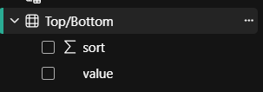
Dynamic rank tp =
IF(
SELECTEDVALUE('Top/Bottom'[value])= "Top",
RANKX(
ALLSELECTED('User Table'[Name]),
[Total Price],
,
DESC,
Dense
),
RANKX(
ALLSELECTED('User Table'[Name]),
[Total Price],
,
ASC,
Dense
)
)

condition =
IF(
[Dynamic rank tp]<= Parameter[Parameter Value],
1,
0
)
Parameter = GENERATESERIES(1, 10, 1)
Parameter Value = SELECTEDVALUE('Parameter'[Parameter])

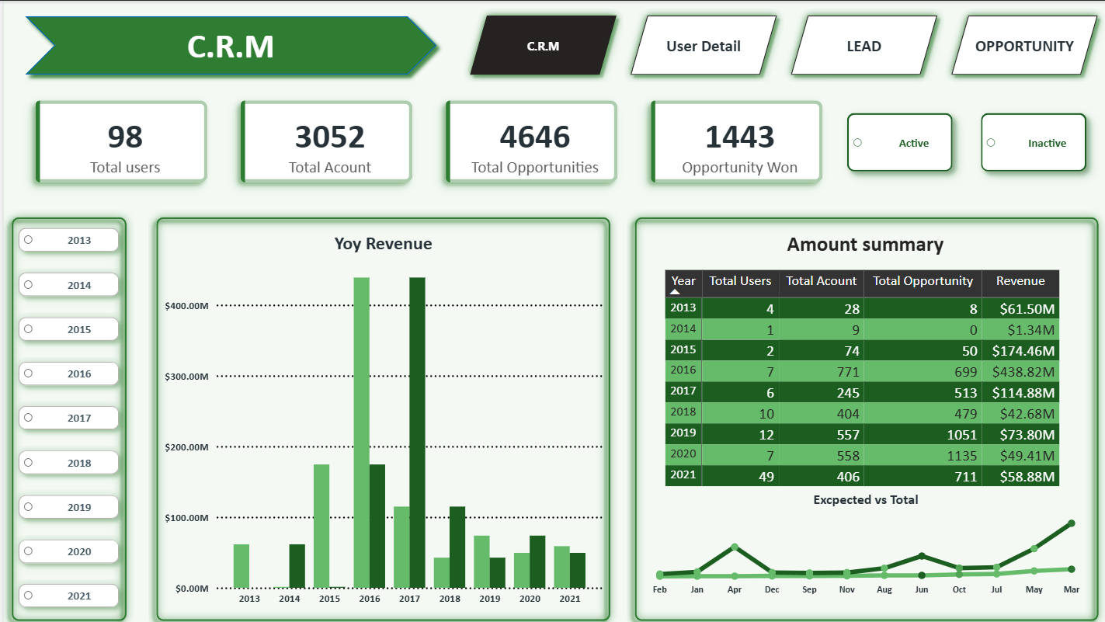
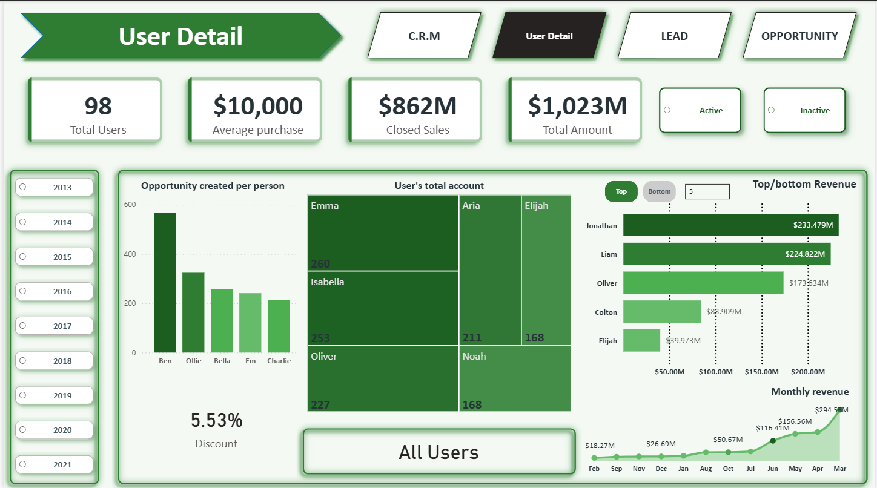
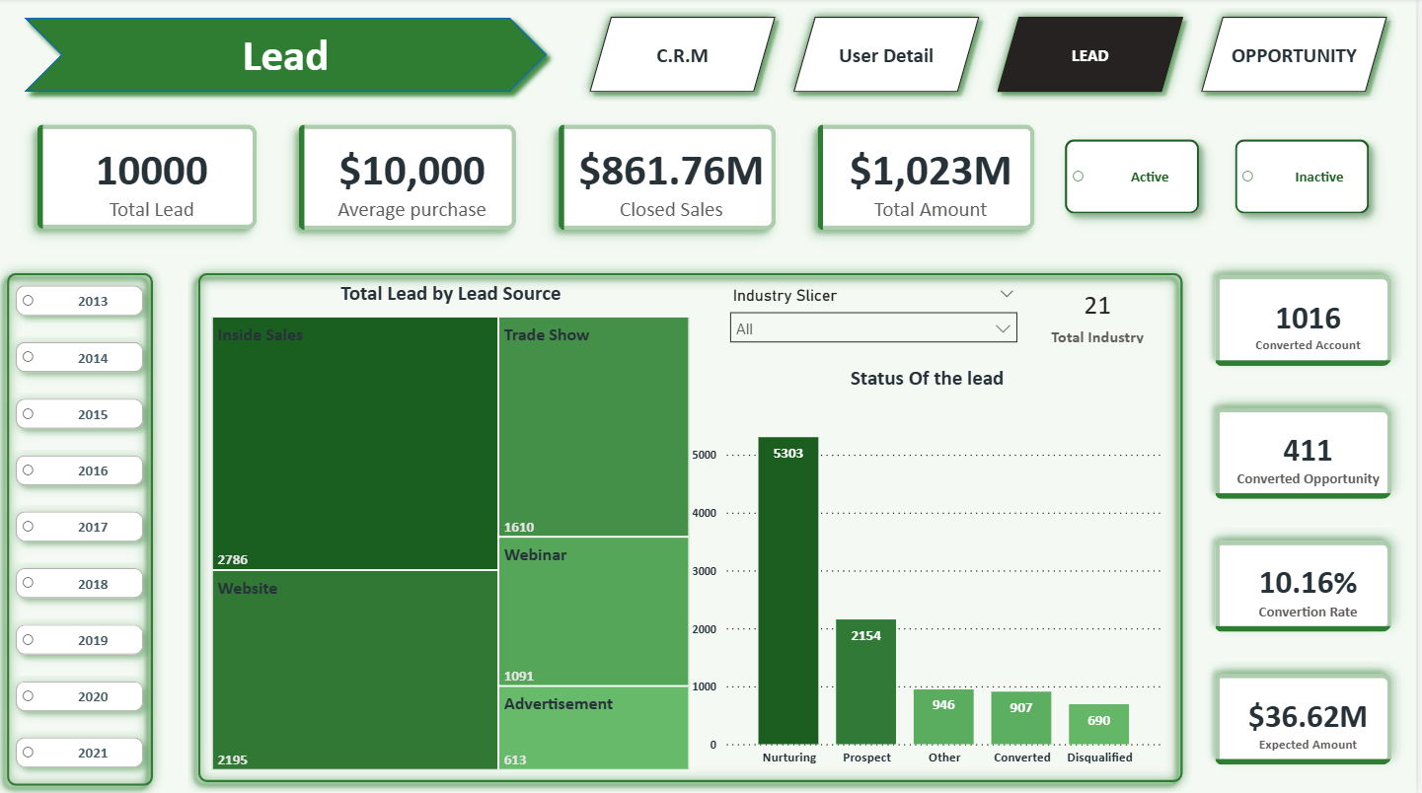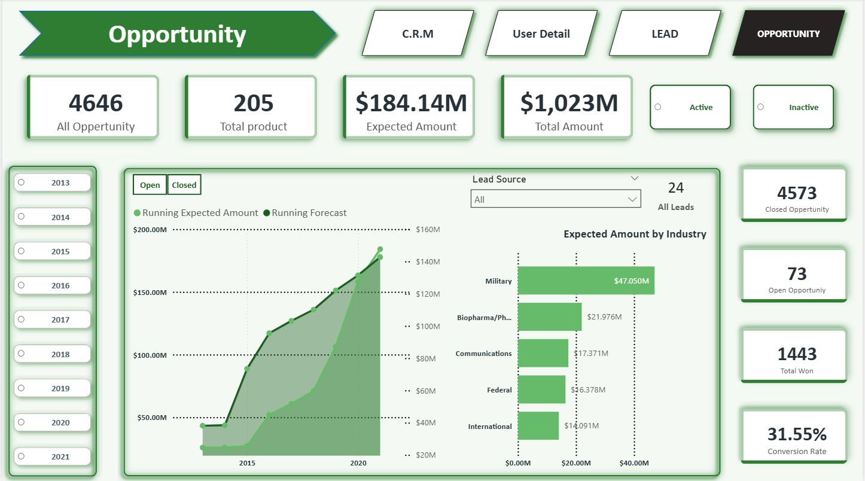

All important tooltip are added in visual.

